Noun Verb Analysis

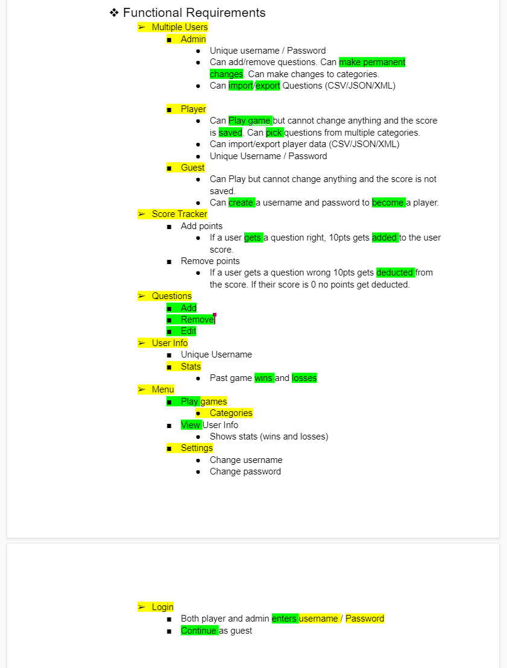

| **Nouns** | **Verbs** |
| --- | --- |
| Some Noun [Some Child] | Some Verb (Some Other Noun) |
| Some Other Noun(Some Attribute) | Some Other Verb (Some Noun) |
| Eliminated Noun | Eliminated Verb |
| Multiple Users [Admin, Player, Guest], (User Info, Stats, Username, Password) | Make permanent changes  import/export(questions)  Play (Game)  Save (Score)  Wins (stats)  losses( stats) |
| Admin |  |
| Player |  |
| Guest |  |
| Score Tracker | add (score)  remove (score) |
| Questions |  |
| User Info |  |
| Stats |  |
| Menu (Categories, Questions, settings) | Add (questions)  Remove (questions)  Edit (questions)  View (User info) |
| Game |  |
| Categories[Questions] |  |
| Settings |  |
| Login | Enters (username, password)  continue (guest) |
| Username |  |
| Password |  |